Wolf Steel

Assigned to: Natasha

Reporting Month: March 2025

# Results and Discussion

## Appendix A

## **Raw Sewage Table**

|  |  |  |  |  |  |  |  |
| --- | --- | --- | --- | --- | --- | --- | --- |
|  | **pH** | **Temp** | **DO** | **BOD5** | **TSS** | **TKN** | **Alk** |
| Units |  | ˚C | mg/L | mg/L | mg/L | mg/L | mg/L |
| 11-Jul-24 | 7.83 | 21.70 | 0.81 | 130 | 142 | 63.30 | 404 |
| 07-Aug-24 | - | 18.90 | 0.71 | 140 | 40.00 | 107 | 669 |
| 04-Sep-24 | 7.45 | 21.50 | 0.67 | 92.00 | 40.00 | 130 | 778 |
| 02-Oct-24 | - | - | - | 95.00 | 39.00 | 129 | 728 |
| 13-Nov-24 | - | 13.00 | 0.60 | 102 | 68.00 | 132 | 743 |
| 11-Dec-24 | - | 11.60 | 1.13 | 56.00 | 38.00 | 138 | 800 |
| 09-Jan-25 | - | 7.10 | 2.67 | 47.00 | 23.00 | 62.00 | 411 |
| 05-Feb-25 | --- | 8.20 | 1.52 | 429 | 110 | 141 | 751 |
| 05-Mar-25 | - | - | - | 354 | 72.00 | 145 | 817 |
| **Average** | **7.64** | **14.57** | **1.16** | **161** | **63.56** | **116** | **678** |
| **Median** | **7.64** | **13.00** | **0.81** | **102** | **40.00** | **130** | **743** |

## **Biofilter Effluent Table**

|  |  |  |  |  |  |  |  |  |  |
| --- | --- | --- | --- | --- | --- | --- | --- | --- | --- |
|  | **pH** | **Temp** | **DO** | **cBOD5** | **TAN** | **NO3** | **NO2** | **TIN** | **Alk** |
| Units |  | ˚C | mg/L | mg/L | mg/L | mg/L | mg/L | mg/L | mg/L |
| 11-Jul-24 | 7.62 | 20.90 | 5.26 | 4.00 | 12.00 | 45.70 | 0.52 | 58.22 | 198 |
| 07-Aug-24 | - | 19.80 | 5.72 | 4.00 | 0.20 | 44.00 | 0.30 | 44.50 | 167 |
| 04-Sep-24 | 7.11 | 21.10 | 5.63 | 4.00 | 0.60 | 62.70 | 0.30 | 63.60 | 108 |
| 02-Oct-24 | - | - | - | 4.00 | 0.90 | 76.00 | 0.30 | 77.20 | 67.00 |
| 13-Nov-24 | - | 5.68 | 14.00 | 4.00 | 1.60 | 88.00 | 0.30 | 89.90 | 47.00 |
| 11-Dec-24 | - | 6.30 | 12.30 | 4.00 | 0.90 | 80.40 | 0.30 | 81.60 | 52.00 |
| 09-Jan-25 | - | 7.13 | 7.60 | 4.00 | 0.70 | 47.80 | 0.30 | 48.80 | 115 |
| 05-Feb-25 | --- | 6.28 | 8.80 | 20.00 | 1.00 | 49.00 | 0.30 | 50.30 | 159 |
| 05-Mar-25 | - | - | - | 4.00 | 1.60 | 50.20 | 0.30 | 52.10 | 153 |
| **Average** | **7.37** | **12.46** | **8.47** | **5.78** | **2.17** | **60.42** | **0.32** | **62.91** | **118** |
| **Median** | **7.37** | **7.13** | **7.60** | **4.00** | **0.90** | **50.20** | **0.30** | **58.22** | **115** |

## **WaterNOx-LS Effluent Table**

|  |  |  |  |  |  |  |  |  |
| --- | --- | --- | --- | --- | --- | --- | --- | --- |
|  | **pH** | **Temp** | **DO** | **cBOD5** | **TAN** | **NO3** | **NO2** | **TIN** |
| Units |  | ˚C | mg/L | mg/L | mg/L | mg/L | mg/L | mg/L |
| 11-Jul-24 | 7.83 | 22.30 | 0.51 | 6.00 | 1.30 | 0.06 | 0.30 | 1.66 |
| 07-Aug-24 | - | 20.30 | 1.20 | 5.00 | 1.00 | 0.06 | 0.30 | 1.36 |
| 04-Sep-24 | 7.35 | 22.10 | 0.66 | 29.00 | 1.00 | 0.06 | 0.30 | 1.36 |
| 02-Oct-24 | - | - | - | 25.00 | 0.50 | 0.06 | 0.30 | 0.86 |
| 13-Nov-24 | - | 14.20 | 0.51 | 30.00 | 0.90 | 0.06 | 0.30 | 1.26 |
| 11-Dec-24 | - | 13.90 | 0.60 | 10.00 | 0.50 | 0.06 | 0.30 | 0.86 |
| 09-Jan-25 | - | 7.10 | 2.21 | 35.00 | 0.10 | 0.06 | 0.30 | 0.46 |
| 05-Feb-25 | --- | 7.20 | 2.61 | 29.00 | 0.10 | 0.06 | 0.30 | 0.46 |
| 05-Mar-25 | - | - | - | 34.00 | 0.10 | 0.06 | 0.30 | 0.46 |
| **Average** | **7.59** | **15.30** | **1.19** | **22.56** | **0.61** | **0.06** | **0.30** | **0.97** |
| **Median** | **7.59** | **14.20** | **0.66** | **29.00** | **0.50** | **0.06** | **0.30** | **0.86** |

## **WaterNOx-S Effluent Table**

|  |  |  |  |  |  |  |  |  |
| --- | --- | --- | --- | --- | --- | --- | --- | --- |
|  | **pH** | **Temp** | **DO** | **cBOD5** | **TAN** | **NO3** | **NO2** | **TIN** |
| Units |  | ˚C | mg/L | mg/L | mg/L | mg/L | mg/L | mg/L |
| 11-Jul-24 | 7.52 | 21.40 | 0.32 | 197 | 12.20 | 0.06 | 0.30 | 12.56 |
| 07-Aug-24 | - | 20.20 | 0.32 | 78.00 | 0.70 | 0.06 | 0.30 | 1.06 |
| 04-Sep-24 | 7.36 | 21.20 | 0.46 | 86.00 | 1.00 | 0.06 | 0.30 | 1.36 |
| 02-Oct-24 | - | - | - | 94.00 | 1.10 | 0.06 | 0.30 | 1.46 |
| 13-Nov-24 | - | 14.40 | 0.39 | 121 | 4.90 | 0.06 | 0.30 | 5.26 |
| 11-Dec-24 | - | 13.20 | 0.37 | 93.00 | 3.00 | 0.06 | 0.30 | 3.36 |
| 09-Jan-25 | - | 2.11 | 7.50 | 89.00 | 0.20 | 0.06 | 0.30 | 0.56 |
| 05-Feb-25 | --- | 8.30 | 2.33 | 165 | 0.10 | 0.06 | 0.30 | 0.46 |
| 05-Mar-25 | - | - | - | 199 | 0.10 | 0.06 | 0.30 | 0.46 |
| **Average** | **7.44** | **14.40** | **1.67** | **125** | **2.59** | **0.06** | **0.30** | **2.95** |
| **Median** | **7.44** | **14.40** | **0.39** | **94.00** | **1.00** | **0.06** | **0.30** | **1.36** |

## **Final Effluent Table**

|  |  |  |  |  |  |  |  |  |  |  |  |  |  |
| --- | --- | --- | --- | --- | --- | --- | --- | --- | --- | --- | --- | --- | --- |
|  | **pH** | **Temp** | **DO** | **cBOD5** | **TSS** | **TKN** | **TAN** | **NO3** | **NO2** | **TN** | **Alk** |  |  |
| Units |  | ˚C | mg/L | mg/L | mg/L | mg/L | mg/L | mg/L | mg/L | mg/L | mg/L |  |  |
| ECA Objective |  |  |  | 10.00 | 10.00 |  |  |  |  | <3.5 |  |  |  |
| ECA Limit |  |  |  | 15.00 | 15.00 |  |  |  |  | 3.50 |  |  |  |
| 23-Jul-24 | 7.91 | 26.80 | 0.00 | 4.00 | 8.00 | 1.40 | 0.70 | 1.75 | 0.30 | 2.45 | 230 | 2.45 |  |
| 07-Aug-24 | - | 19.90 | 1.88 | 4.00 | 4.00 | 1.10 | 0.60 | 0.50 | 0.30 | 1.10 | 211 |  |  |
| 21-Aug-24 | - | - | - | 15.00 | 8.00 | 1.40 | 0.70 | 0.06 | 0.30 | 0.76 | 147 | 0.93 |  |
| 04-Sep-24 | 7.66 | 21.80 | 0.92 | 7.00 | 6.00 | 1.00 | 0.80 | 0.06 | 0.30 | 0.86 | 169 |  |  |
| 18-Sep-24 | 7.99 | 22.40 | 0.00 | 10.00 | 3.00 | 2.20 | 1.50 | 0.06 | 0.30 | 1.56 | 168 | 1.21 |  |
| 02-Oct-24 | - | - | - | 4.00 | 7.00 | 2.20 | 1.60 | 0.06 | 0.30 | 1.66 | 135 |  |  |
| 16-Oct-24 | 8.36 | 11.90 | 0.00 | 5.00 | 6.00 | 1.70 | 1.00 | 6.16 | 0.30 | 7.16 | 147 |  |  |
| 30-Oct-24 | - | 12.60 | 10.58 | 4.00 | 6.00 | 1.80 | 1.00 | 3.06 | 0.48 | 4.06 | 133 | 4.29 |  |
| 13-Nov-24 | - | 13.10 | 0.44 | 5.00 | 12.00 | 1.40 | 1.00 | 0.06 | 0.30 | 1.06 | 161 |  |  |
| 27-Nov-24 | - | 14.40 | 1.51 | 4.00 | 6.00 | 1.70 | 0.90 | 0.26 | 0.30 | 1.16 | 167 | 1.11 |  |
| 11-Dec-24 | - | 15.60 | 1.20 | 5.00 | 2.00 | 1.10 | 0.50 | 0.52 | 0.30 | 1.02 | 163 |  |  |
| 23-Dec-24 | - | 8.70 | 5.27 | 10.00 | 16.00 | 0.70 | 0.10 | 0.06 | 0.30 | 0.16 | 146 | 0.59 | 2.33 |
| 09-Jan-25 | - | 6.70 | 2.62 | 5.00 | 3.00 | 0.90 | 0.10 | 0.06 | 0.30 | 0.16 | 215 |  |  |
| 21-Jan-25 | - | 4.80 | 5.08 | 12.00 | 10.00 | 0.80 | 0.20 | 0.65 | 0.30 | 0.85 | 195 | 0.51 |  |
| 05-Feb-25 | - | 3.30 | 2.54 | 12.00 | 8.00 | 0.60 | 0.10 | 0.06 | 0.30 | 0.16 | 198 |  |  |
| 19-Feb-25 | - | 10.40 | 3.16 | 5.00 | 2.00 | 0.80 | 0.10 | 0.14 | 0.30 | 0.24 | 222 | 0.20 |  |
| 05-Mar-25 | - | - | - | 7.00 | 5.00 | 0.90 | 0.30 | 0.06 | 0.30 | 0.36 | 185 |  |  |
| 21-Mar-25 | - | - | - | 18.00 | 14.00 | 0.50 | 0.20 | 0.06 | 0.30 | 0.26 | 263 | 0.31 |  |
| **Average** | **7.98** | **13.74** | **2.51** | **7.56** | **7.00** | **1.23** | **0.63** | **0.76** | **0.31** | **1.39** | **181** | **1.29** | **2.33** |
| **Median** | **7.95** | **12.85** | **1.69** | **5.00** | **6.00** | **1.10** | **0.65** | **0.06** | **0.30** | **0.94** | **168** | **0.93** | **2.33** |

# Appendix B: Flow Data — January 2025

## Jan 25

|  |  |  |  |
| --- | --- | --- | --- |
| Date | Flowmeter 1 Total (L) | Flowmeter 1 (L/day) | Total Daily Flow (L/day) |
| 01-Jan-25 | 4028133 | 12664 | 12664 |
| 02-Jan-25 | 4040589 | 12456 | 12456 |
| 03-Jan-25 | 4052566 | 11977 | 11977 |
| 04-Jan-25 | 4061401 | 8835 | 8835 |
| 05-Jan-25 | 4066697 | 5296 | 5296 |
| 06-Jan-25 | 4073714 | 7017 | 7017 |
| 07-Jan-25 | 4084707 | 10993 | 10993 |
| 08-Jan-25 | 4097014 | 12307 | 12307 |
| 09-Jan-25 | 4110478 | 13464 | 13464 |
| 10-Jan-25 | 4123816 | 13338 | 13338 |
| 11-Jan-25 | 4136761 | 12945 | 12945 |
| 12-Jan-25 | 4138710 | 1949 | 1949 |
| 13-Jan-25 | 4144112 | 5402 | 5402 |
| 14-Jan-25 | 4158092 | 13980 | 13980 |
| 15-Jan-25 | 4170278 | 12186 | 12186 |
| 16-Jan-25 | 4182696 | 12418 | 12418 |
| 17-Jan-25 | 4196109 | 13413 | 13413 |
| 18-Jan-25 | 4208000 | 11891 | 11891 |
| 19-Jan-25 | 4211559 | 3559 | 3559 |
| 20-Jan-25 | 4215439 | 3880 | 3880 |
| 21-Jan-25 | 4228283 | 12844 | 12844 |
| 22-Jan-25 | 4241697 | 13414 | 13414 |
| 23-Jan-25 | 4253355 | 11658 | 11658 |
| 24-Jan-25 | 4265838 | 12483 | 12483 |
| 25-Jan-25 | 4271195 | 5357 | 5357 |
| 26-Jan-25 | 4271196 | 1 | 1 |
| 27-Jan-25 | 4277113 | 5917 | 5917 |
| 28-Jan-25 | 4290490 | 13377 | 13377 |
| 29-Jan-25 | 4303194 | 12704 | 12704 |
| 30-Jan-25 | 4310809 | 7615 | 7615 |
| 31-Jan-25 | 4323546 | 12737 | 12737 |
| Total Flow (L) |  |  | 308077 |
| Average Flow (L/day) |  |  | 9938 |

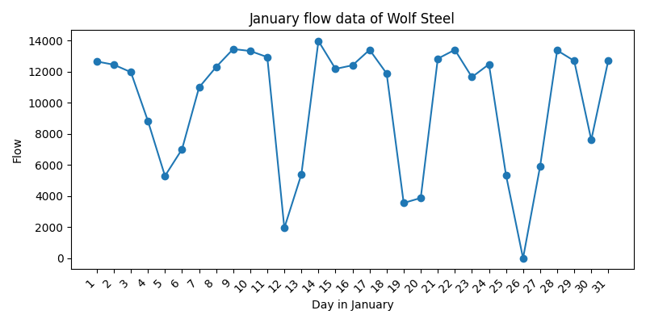

# Appendix C: Site Notes

# Appendix B: Flow Data — February 2025

## Feb 25

|  |  |  |  |
| --- | --- | --- | --- |
| Date | Flowmeter 1 Total (L) | Flowmeter 1 (L/day) | Total Daily Flow (L/day) |
| 01-Feb-25 | 4331766 | 8220 | 8220 |
| 02-Feb-25 | 4331766 | 0 | 0 |
| 03-Feb-25 | 4336825 | 5059 | 5059 |
| 04-Feb-25 | 4349596 | 12771 | 12771 |
| 05-Feb-25 | 4363201 | 13605 | 13605 |
| 06-Feb-25 | 4371109 | 7908 | 7908 |
| 07-Feb-25 | 4383209 | 12100 | 12100 |
| 08-Feb-25 | 4386431 | 3222 | 3222 |
| 09-Feb-25 | 4386431 | 0 | 0 |
| 10-Feb-25 | 4392937 | 6506 | 6506 |
| 11-Feb-25 | 4404781 | 11844 | 11844 |
| 12-Feb-25 | 4412368 | 7587 | 7587 |
| 13-Feb-25 | 4424829 | 12461 | 12461 |
| 14-Feb-25 | 4431026 | 6197 | 6197 |
| 15-Feb-25 | 4437763 | 6737 | 6737 |
| 16-Feb-25 | 4437763 | 0 | 0 |
| 17-Feb-25 | 4437763 | 0 | 0 |
| 18-Feb-25 | 4446764 | 9001 | 9001 |
| 19-Feb-25 | 4456602 | 9838 | 9838 |
| 20-Feb-25 | 4469563 | 12961 | 12961 |
| 21-Feb-25 | 4477890 | 8327 | 8327 |
| 22-Feb-25 | 4487956 | 10066 | 10066 |
| 23-Feb-25 | 4487956 | 0 | 0 |
| 24-Feb-25 | 4493111 | 5155 | 5155 |
| 25-Feb-25 | 4506266 | 13155 | 13155 |
| 26-Feb-25 | 4519566 | 13300 | 13300 |
| 27-Feb-25 | 4533296 | 13730 | 13730 |
| 28-Feb-25 | 4546456 | 13160 | 13160 |
| Total Flow (L) |  |  | 222910 |
| Average Flow (L/day) |  |  | 7961 |

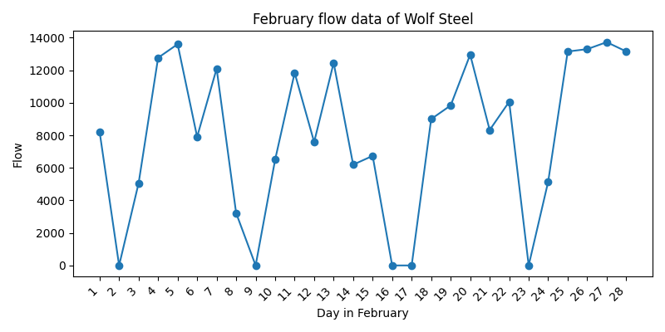

# Appendix C: Site Notes

# Appendix B: Flow Data — March 2025

## Mar 25

|  |  |  |  |
| --- | --- | --- | --- |
| Date | Flowmeter 1 Total (L) | Flowmeter 1 (L/day) | Total Daily Flow (L/day) |
| 01-Mar-25 | 4559214 | 12758 | 12758 |
| 02-Mar-25 | 4559214 | 0 | 0 |
| 03-Mar-25 | 4567514 | 8300 | 8300 |
| 04-Mar-25 | 4579992 | 12478 | 12478 |
| 05-Mar-25 | 4593955 | 13963 | 13963 |
| 06-Mar-25 | 4606515 | 12560 | 12560 |
| 07-Mar-25 | 4619522 | 13007 | 13007 |
| 08-Mar-25 | 4632810 | 13288 | 13288 |
| 09-Mar-25 | 4644814 | 12004 | 12004 |
| 10-Mar-25 | 4657101 | 12287 | 12287 |
| 11-Mar-25 | 4668912 | 11811 | 11811 |
| 12-Mar-25 | 4680460 | 11548 | 11548 |
| 13-Mar-25 | 4693602 | 13142 | 13142 |
| 14-Mar-25 | 4705175 | 11573 | 11573 |
| 15-Mar-25 | 4719052 | 13877 | 13877 |
| 16-Mar-25 | 4736744 | 17692 | 17692 |
| 17-Mar-25 | 4754540 | 17796 | 17796 |
| 18-Mar-25 | 4771948 | 17408 | 17408 |
| 19-Mar-25 | 4787667 | 15719 | 15719 |
| 20-Mar-25 | 4804179 | 16512 | 16512 |
| 21-Mar-25 | 4820834 | 16655 | 16655 |
| 22-Mar-25 | 4833796 | 12962 | 12962 |
| 23-Mar-25 | 4847106 | 13310 | 13310 |
| 24-Mar-25 | 4859749 | 12643 | 12643 |
| 25-Mar-25 | 4871911 | 12162 | 12162 |
| 26-Mar-25 | 4884819 | 12908 | 12908 |
| 27-Mar-25 | 4897850 | 13031 | 13031 |
| 28-Mar-25 | 4909842 | 11992 | 11992 |
| 29-Mar-25 | 4918746 | 8904 | 8904 |
| 30-Mar-25 | - |  | 4404 |
| 31-Mar-25 | - | - | 4404 |
| Total Flow (L) |  |  | 381098 |
| Average Flow (L/day) |  |  | 12293 |

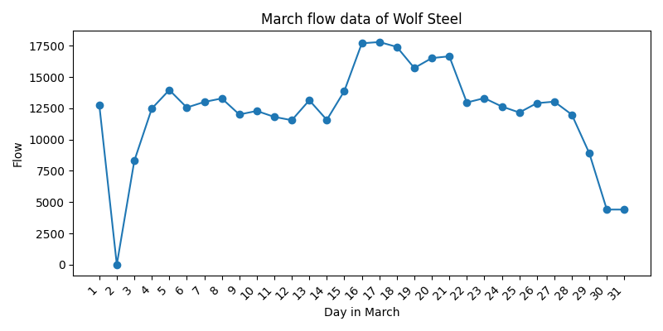

# Appendix C: Site Notes